COMPUTER
SCIENCE PROJECT

MOBILE STOCK MANAGEMENT

SUBMITTED TO-:
Mrs.SUMAN TANEJA

SUBMITTED BY-:
PARUL SHANDILYA & PALASH JAIN
Of Class XII-B
MAHAVEER PUBLIC SCHOOL

INDEX

- CERTIFICATE
- ACKNOWLEDGEMENT
- INTRODUCTION
- WHAT IS C++?
- SOFTWARE & HARDWARE REQUIRMENT
- HEADER FILES INCLUDED
- VARIOUS MENUES WHICH CAN BE SEE IN

THE PROGRAM

- FILE GENERATED
- FUNCTION USED
- CLASS USED
- ADVANTAGES
- DISADVANTAGES
- PROGRAMMING
- SNAPSHOTS
- BIBLIOGRAPHY

CERTIFICATE

Certified to be the bonafide work done by
Palash Jain and Parul Shandilya of class XII-B in the Computer Science during the academic session 2014-2015

Roll Number-
Parul Shandilya – 1627501
Palash Jain - 1627500

Mahaveer Public School
Vardaman Path
Mahaveer Marg
C-Scheme Jaipur

Submitted for All India Senior Secondary Examination Held on 11 Feb 2015 at Mahaveer Public School, Jaipur
Examiner Mrs. Suman Taneja
Date:11/02/15

ACKNOWLEDGEMENT

I would like to express my sincere gratitude to my chemistry mentor Mrs. SUMAN TANEJA, for her vital support, guidance and encouragement. I would also like to thank my parents -without which this project would not have come forth.

INTRODUCTION

This project is an elementary program computed in C++ language for mobile shop management. This project has covered all infrastructure of the basic shop management program. It will allow user to enter data edit them and delete them.

WHAT IS C++?

C++ is a general-purpose programming language. It has imperative, object-oriented and generic programming features, while also providing the facilities for low-level memory manipulation. It is designed with a bias toward system programming with performance, efficiency and flexibility of use as its design requirements. C++ has also been found useful in many other contexts, including desktop applications, servers and performance-critical applications and entertainment software C++ is a compiled. The C++ programming language was initially standardized in 1998 as ISO/IEC 14882:1998, which was then amended by the C++03, ISO/IEC 14882:2003, standard. The current C++11 standard supersedes these, with new features and an enlarged standard library. Before the initial standardization in 1998, C++ was developed by Bjarne Stroustrup at Bell Labs, starting in 1979, who wanted an efficient flexible language which also provided high-level features for program organization.

SOFTWARE & HARDWARE REQUIRMENT-:
- BL turbo C++
- Windows 98
- Pentium(R) 4 CPU 3.06GHz
3.07 GHz, 512MB of RAM
- Hard disk 500GB
HEADER FILES INCLUDE:
- <fstream> for reading and writing files
- <conio> for clrscr() and getch()
- <string> for string characters
- <stdio> for gets() and puts()
- <stdlib> for exit function
- <dos> for delay function
- <graphics> for text colour and text background

VARIOUS MENUS WHICH CAN BE SEEN IN THE PROGRAM
  - Generate bill
  - Add stock
  - Search stock
  - Delete a stock
  - Modify a stock
  - Display all stock
  - Exit
FILE GENERATED IS
MOBILE_S.DAT
FUNCTION USED—
    - void add_stock();
    - void search_stock();
    - void delete_stock();
    - void mod_com_name();
    - void mod_mod_name();
    - void ser_com_name();
    - void ser_mod_name();
    - void page1();
    - void page2();
    - void main_menu();
    - void display_stocks();
    - void display();
    - void generate_bill();
    - void modify_stocks();

CLASS USED
- Bill
Data member
- char name[50]
- char model_name[50]
- char colour[20]
- char imei[15]
- float price
Member Function
- getdata()
- generate_bill()

ADVANTAGES
- User friendly
- Easy to handle
- Quick assessable
- Reliable
- Easy to understand
- Easy to work on program
- Ensure proper tracking of products

DISADVANTAGES
- It is basically a command based program which lacks graphics user interference.
- In editing part whole the record has to be entered again.
- Images cannot be seen.
- Can be used only when c++ is installed.
- PC should have required configurations.

PROGRAMMING

#include<conio.h>
#include<string.h>
#include<stdio.h>
#include<stdlib.h>
#include<fstream.h>
#include<dos.h>
#include<graphics.h>

void add_stock(); //To Add Record
void search_stock(); //To Search Stock
void delete_stock(); //To Delete Stock
void mod_com_name(); //TO Modify with respect to Company name
void mod_mod_name(); //TO Modify with respect to Model name
void ser_com_name(); //TO Search with respect to Company name
void ser_mod_name(); //TO Search with respect to Model name
void page1(); //I page of Program
void page2(); //II page of Program
void main_menu(); // Main Menu of Program
void display_stocks(); //To Display Records Entered
void display(); //To Display Records Entered
void generate_bill(); //TO Generate Bill
void modify_stocks(); //To Modify Stock

//*****************************************************
class bill
{
char company_name[50];
char model_name[50];
char colour[20];
float price;
float tprice;
int qty;
public:
char* getcomp()
{
return company_name;
}
char* getmod()
{
return model_name;
}
int getqty()
{
return qty;
}
float getpri()
{
return price;
}
void getdata()
{
cout<<"\nENTER COMPANY NAME\t\t\t";
gets(company_name);
cout<<"ENTER MODEL NAME\t\t\t";
gets(model_name);

cout<<"ENTER COLOUR\t\t\t\t";
gets(colour);
cout<<"ENTER QUANTITY\t\t\t\t";
cin>>qty;
cout<<"ENTER PRICE OF EACH MOBILE\t\t";
cin>>price;
}
void putdata()
{
cout<<"\n\n\n COMPANY NAME\t\t\t";
puts(company_name);
cout<<" MODEL NAME \t\t\t";
puts(model_name);
cout<<" COLOUR \t\t\t";
puts(colour);
cout<<" QUNTITY \t\t\t";
cout<<qty;
cout<<"\n PRICE OF EACH MOBILE\t\t";
cout<<price;
tprice=price*qty;
cout<<"\n TOTAL PRICE OF STOCK \t"<<tprice;
}
void calc_price();

};

//*********************************************************
void main()
{
clrscr();

page1();
page2();
main_menu();

getch();
}

//********************************************************
//ADD STOCK FUNCTION

void add_stocks()
{
clrscr();

textbackground(5);
textcolor(15);

bill wd; char ch;
cout<<"\n\n\t\t\t###################";
cout<<"\n\t\t\t# ADD STOCK #";
cout<<"\n\t\t\t###################\n";
do{
ofstream ofs("mobile_stocks.dat",ios::in|ios::binary|ios::app);
wd.getdata();
ofs.write((char*)&wd,sizeof(wd));
cout<<"\n\n\tDO YOU WANT TO ENTER MORE :\t";
cin>>ch;
}while(ch=='y');
main_menu();
}

void bill::calc_price()
{
bill bomb;
int s;
ifstream ifs("mobile_stocks.dat",ios::in|ios::binary);
while(!ifs.eof())
{
s=strcmp(bomb.model_name,model_name);
if(s==0)
{
price=bomb.price;
}
ifs.close();
tprice=price*qty;

}

}
//*********************************************************
//SEARCH STOCK FUNCTION

void search_stock()
{l:

clrscr();
textbackground(5);
textcolor(15);
int ch;
cout<<"\n\n\t\t\t###################";
cout<<"\n\t\t\t# SEARCH STOCK #";

cout<<"\n\t\t\t###################";
cout<<"\n\n\n\t\t1. COMPANY NAME\n";
cout<<"\t\t2. MODEL NAME ";

cout<<"\n\t\tSEARCH WITH RESPECT TO ";
cin>>ch;
clrscr();
if(ch==1)
{
ser_com_name();
}
else if(ch==2)
{
ser_mod_name();
}
else
{cout<<"\n\t\tNOT A VALID ENTERY!!\n\t\t ENTER CORRECT CHOICE";
delay(400);
goto l;
}

getch(); main_menu();
}
//SEARCHING WITH RESPECT TO COMPANY NAME
void ser_com_name()
{
bill m;
char com_name[50];
int i=1;

cout<<"\n\n\t\t\t###################";
cout<<"\n\t\t\t# SEARCH STOCK #";
cout<<"\n\t\t\t###################";
cout<<"\n\nENTER COMPANY NAME WANT TO SEARCH ";
gets(com_name);
ifstream ifs("mobile_stocks.dat",ios::in|ios::binary);
while(ifs.read((char*)&m,sizeof(m)))
{

if(strcmp(m.getcomp(),com_name)==0)
{
m.putdata();
i=0;
}
}
if(i!=0)
{

cout<<"\nNO STOCK FOUND";
}
ifs.close();

}
//**********************************************************
//SEARCHING WITH RESPECT TO MODEL NAME
void ser_mod_name()
{
bill m;
char mod_name[50];
int i=1;
cout<<"\n\n\t\t\t###################";
cout<<"\n\t\t\t# SEARCH STOCK #";
cout<<"\n\t\t\t###################";
cout<<"\n\n\nENTER MODLE NAME WANT TO SEARCH ";
gets(mod_name);
ifstream ifs("mobile_stocks.dat",ios::in|ios::binary);
while(ifs.read((char*)&m,sizeof(m)))
{

if(strcmp(m.getmod(),mod_name)==0)
{
m.putdata();
i=0;
}
}
if(i!=0)
{
cout<<"\nNO STOCK FOUND";
}
ifs.close();
}
//*********************************************************
//GENERATE BILL FUNCTION
void generate_bill()
{ clrscr();
textbackground(5);
textcolor(15);
char cname[50]; bill m;
float p_discount,t;
int d;
char mobile_no[10];
cout<<"\n\n\t\t\t###################";
cout<<"\n\t\t\t# GENERATE BILL #";
cout<<"\n\t\t\t###################";
cout<<"\n\nENTER CUSTOMER NAME\t\t";

gets(cname);
cout<<"ENTER CUSTOMER MOBILE NUMBER\t";
gets(mobile_no);
cout<<"\n\n\tENTER MOBILE DETAILS\n\n";

m.getdata();
clrscr();

cout<<"===========================================================================";
cout<<"=\t\t\t\t INVOICE\t\t\t\t" ;
cout<<"\n\n\t Shop 18, WTP, JLN road, Jaipur";
cout<<"\n\t Mobile No.9875695647\n";
cout<<"\n================================================================================";

cout<<"\n\tCustomer Detail\n\n CUSTOMER NAME\t\t";
puts(cname);
cout<<"\n MOBILE NUMBER\t\t"<<mobile_no<<"\n\n\tMobile Details";
m.putdata();
t=m.getpri();
d=m.getqty();
cout<<"\n\n\t\tAMOUNT PAID\t\t"<<t*d;

getch();
}
//********************************************************
//INTRODUCTION PAGE OF PROJECT
void page1()
{
textbackground(1);
textcolor(15);
clrscr();
cout<<"==============================================================================";
cout<<"\n\t\t\t WELCOME TO C++ PROJECT ";
cout<<"\n\n\n\n\t\t\t MOBILE STOCK MANAGEMENT\n\n\n ";
cout<<"\n\tMADE BY : PARUL SHANDILYA & PALASH JAIN\n\n\n";
cout<<"\tCLASS : XII - B\n\n\n ";
cout<<" SCHOOL : MAHAVEER PUBLIC SCHOOL ";
cout<<"\n\n\tSUBMITTED TO : Mrs. SUMAN TANEJA ";
cout<<"\n\n\n==============================================================================";
cout<<"\n\t\tPRESS ENTER TO CONTINUE";

getch();
}

//********************************************************
//SECOND PAGE OF PROGRAM

void page2()
{

textbackground(4);
textcolor(15);
clrscr();
cout<<"================================================================================";

cout<<"\n\n\n\n\n\n\n\t\t\t######################################\n\t\t\t#\t\t\t\t #";
cout<<"\n\t\t\t# \t WELCOME\t\t #\n\t\t\t#\t\t TO\t\t #\n\t\t\t#\tSTORE STOCK MANAGEMENT\t #\n\t\t #\t\t\t\t #";
cout<<"\n\t\t\t######################################\n\n\n\n\n\n\n\n";
cout<<"================================================================================";
cout<<"\n\t\t\t\t Loading";
for(int i=0;i<10;i++)
{
cout<<".";
delay(300);
}
}
//*******************************************************
//MAIN MENU
void main_menu()
{ clrscr();
textbackground(2);
textcolor(15);
int c;
char ch;
l: clrscr();
cout<<"################################################################################";
cout<<"\n \t\t\t\t MAIN MENU\t\t\t\t " ;

cout<<"\n################################################################################";
cout<<"\n================================================================================";
cout<<"\n\t\t\t1.\tGENERATE BILL";
cout<<"\n\n\t\t\t2.\tADD STOCK";

cout<<"\n\n\t\t\t3.\tMODIFY STOCK";
cout<<"\n\n\t\t\t4.\tSEARCH STOCK";
cout<<"\n\n\t\t\t5.\tDELETE STOCK";
cout<<"\n\n\t\t\t6.\tDISPLAY STOCK";
cout<<"\n\n\t\t\t7.\tEXIT \n";
cout<<"================================================================================";
cout<<"\n\t\tENTER YOUR CHOICE : ";
cin>>c;

if(c==1)
{
generate_bill();
}
else if(c==2)
{
add_stocks();
}
else if(c==3)
{
modify_stocks();
}
else if(c==4)
{
search_stock();
}

else if(c==5)
{
delete_stock();
}
else if(c==6)
{
display();
}
else if(c==7)
{
exit(0);
}
goto l;
}
//********************************************************
//TO DISPLAY STOCK
void display()
{
textbackground(5);
textcolor(15);

clrscr();
cout<<"\n\n\t\t\t###################";
cout<<"\n\t\t\t# DISPLAY STOCK #";
cout<<"\n\t\t\t###################";

display_stocks();
}
void display_stocks()
{

bill wd; char ch;
ifstream ifs("mobile_stocks.dat",ios::in|ios::binary); while(ifs.read((char*)&wd,sizeof(wd)))
{
wd.putdata();
}
cout<<"\n\n";
ifs.close();
getch();
}
//*************************************************************
//TO DELETE STOCK
void delete_stock()
{
textbackground(0);
textcolor(15);
char ch;
bill st; char comp[46];
int flag=0;

clrscr();
do{
cout<<"\n\t\t\t\t###################";
cout<<"\n\t\t\t\t# DELETE STOCK #";
cout<<"\n\t\t\t\t###################";
display_stocks();
cout<<"\n ENTER THE COMPANY NAME OF THE STOCK WANT TO DELETE: ";
gets(comp);
fstream fp("mobile_stocks.dat",ios::in|ios::binary);
ofstream fp2("to.dat",ios::out|ios::binary);
fp.seekg(0,ios::beg);
while(fp.read((char*)&st,sizeof(st)))
{
if(strcmp(comp,st.getcomp())!=0)
{
fp2.write((char*)&st,sizeof(st));
}
else
{
flag=1;
}
}
fp2.close();
fp.close();
remove("mobile_stocks.dat");
rename("to.dat","mobile_stocks.dat");
if(flag==1)
{ cout<<"\n RECORD DELETED";
}
else
{
cout<<"\n RECORD NOT FOUND";
}
cout<<"\n DO YOU WANT TO DELETE MORE ";
cin>>ch;
}while(ch=='y');
getch();
}
//***********************************************************
//MODIFY WITH RESPECT TO COMPANY NAME

void modify_stock1()

{
textbackground(5);
textcolor(15);
fstream fp;
bill st;
char comp[46];
int found=0;
clrscr();
cout<<"\n\t\t\t ###################";
cout<<"\n\t\t\t # MODIFY STOCK #";
cout<<"\n\t\t\t ###################";
cout<<"\n\n\t ENTER THE COMPANY NAME WHOSE STOCK YOU WANT TO MODIFY\t";
gets(comp);
fp.open("mobile_stocks.dat",ios::in|ios::out|ios::binary);
while(fp.read((char*)&st,sizeof(st)) && found==0)
{
if(!strcmp(comp,st.getcomp()))
{
st.putdata();
cout<<"\n\nENTER THE NEW DETAILS OF THE STOCK"<<endl;
st.getdata();
int pos=-1*sizeof(st);
fp.seekp(pos,ios::cur);
fp.write((char*)&st,sizeof(st));
cout<<"\n RECORD UPDATED!!";
found=1;
}
}
fp.close();
if(found==0)
cout<<"\n\n RECORD NOT FOUND!!";
getch();
}
//MODIFY WITH RESPECT TO MODEL NAME
void modify_stock2()
{
textbackground(5);
textcolor(15);
fstream fp;
bill st;
char mod[46];
int found=0;
clrscr();
cout<<"\n\t\t\t\t ###################";
cout<<"\n\t\t\t\t # MODIFY STOCK #";

cout<<"\n\t\t\t\t ###################";
cout<<"\n\n\t ENTER THE MODEL NAME WHOSE RECORD WANT TO BE MODIFY\t";
gets(mod);
fp.open("mobile_stocks.dat",ios::in|ios::out|ios::binary);
while(fp.read((char*)&st,sizeof(st)) && found==0)
{
if(!strcmp(mod,st.getmod()))
{
st.putdata();
cout<<"\n\nENTER THE NEW DETAILS OF THE STOCK"<<endl;
st.getdata();
int pos=-1*sizeof(st);
fp.seekp(pos,ios::cur);
fp.write((char*)&st,sizeof(st));
cout<<"\n RECORD UPDATED!!";
found=1;
}
}
fp.close();
if(found==0)
cout<<"\n\nSORRY RECORD NOT FOUND!!";
getch();
}
//*********************************************
//MODIFY STOCK
void modify_stocks()
{
textbackground(5);
textcolor(15);
clrscr();
int ch;
cout<<"\n\t\t\t\t ###################";
cout<<"\n\t\t\t\t # MODIFY STOCK #";
cout<<"\n\t\t\t\t ###################";
cout<<"\n\n\n\t\t\t\t 1. COMPANY NAME\n";
cout<<"\t\t\t\t 2. MODEL NAME ";
l:
cout<<"\n\n\t\t\tMODIFY WITH RESPECT TO ";
cin>>ch;
clrscr();
if(ch==1)
{
modify_stock1();
}
else if(ch==2)
{
modify_stock2();
}
else
{cout<<"NOT VALID ENTERY";goto l;}
}

SNAPSHOTS

WELCOME PAGE
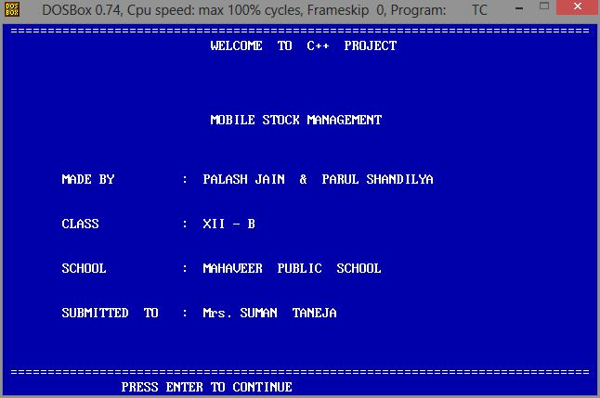
SECOND PAGE
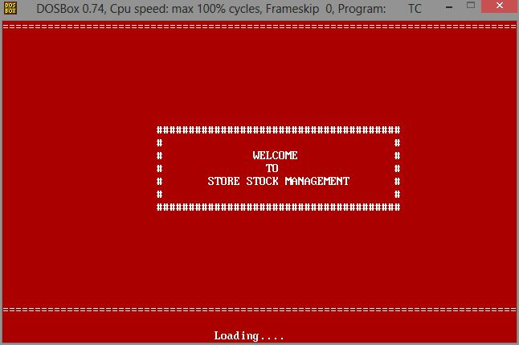
MAIN MENU
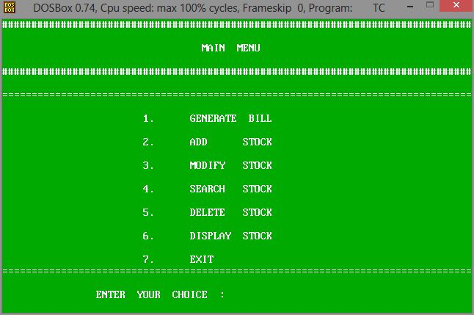

GENERATE BILL
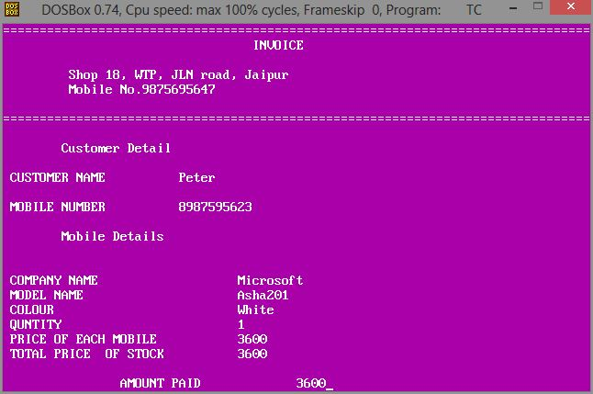
ADD RECORD
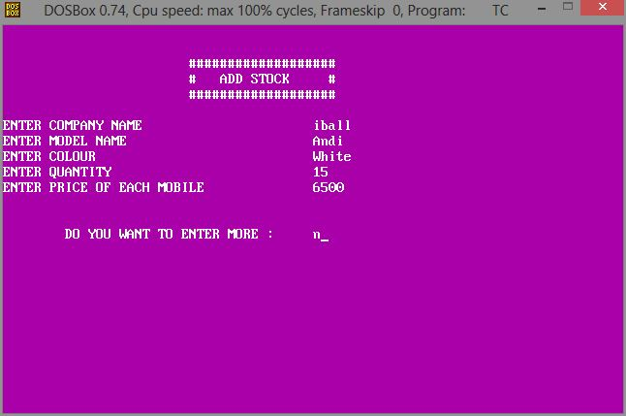

MODIFY RECORD
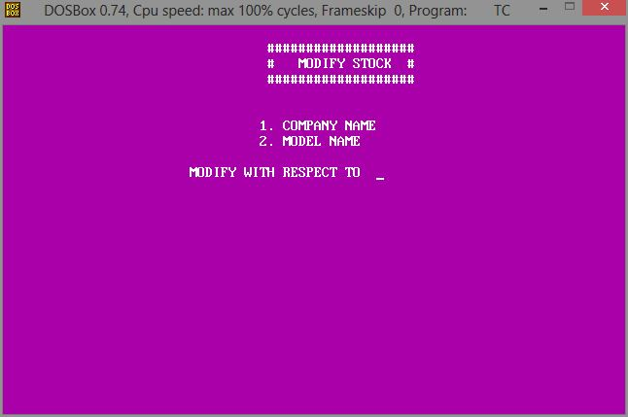
MODIFY WITH RESPECT TO COMPANY NAME 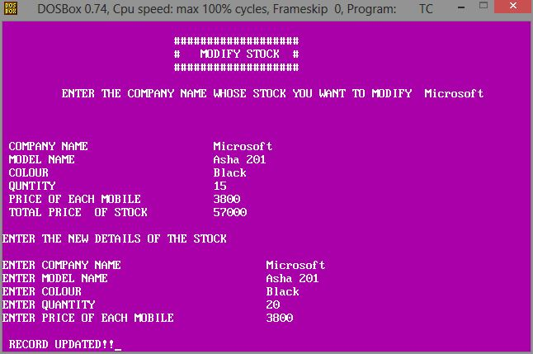

MODIFY WITH RESPECT TO MODEL NAME
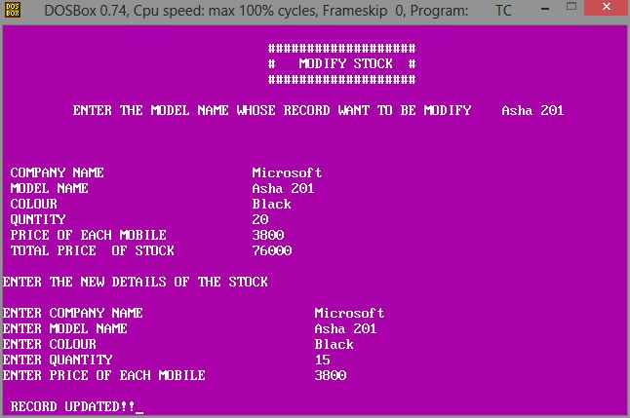

SEARCH RECORD PAGE 1
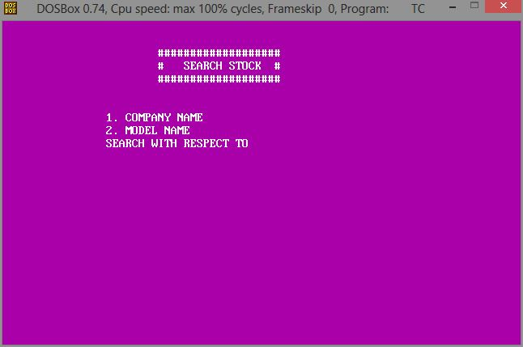
SEARCH WITH RESPECT TO COMPANY NAME
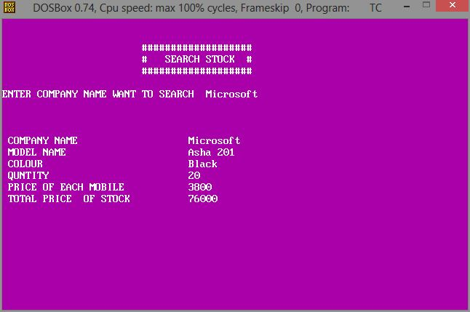

SEARCH WITH RESPECT TO MODEL NAME
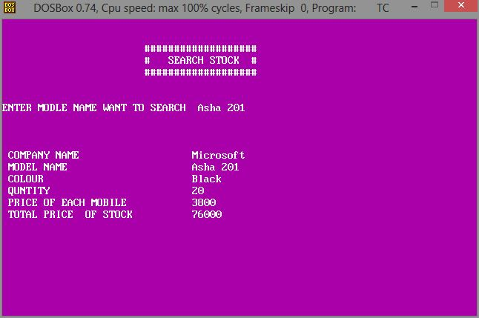
DELETE RECORD
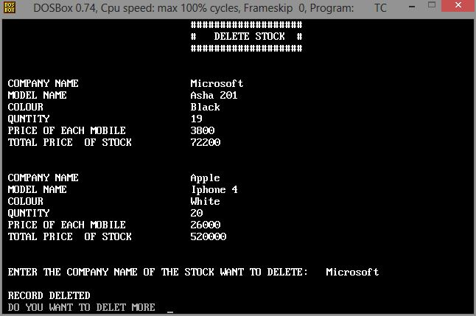

DISPLAY RECORD
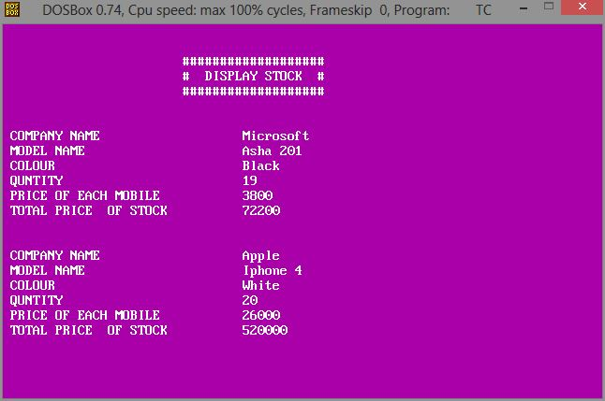

BIBLIOGRAPHY

I have taken help from
- Computer lab
- Google
- Wikipedia
- Computer Science with C++ by Sumita Arora
- icbse.com

